An instance can have two types of volumes:

* **Root volume:** The root volume is the default volume that is attached to an instance when it is launched. It contains the operating system and other essential files for the instance to boot.
* **EBS volume:** EBS volumes are optional volumes that can be attached to an instance to provide additional storage space. They are created from snapshots, which are copies of an existing EBS volume.

**EC2 Dashboard:**

* Region-specific, each region operates independently.
* Multinational clients may have infrastructure in multiple countries.

**Hands-on:**

Launch one instance in Mumbai region(demo) and other in Singapore region(test).

Demo instance have both Root and EBS volume (10 GiB).

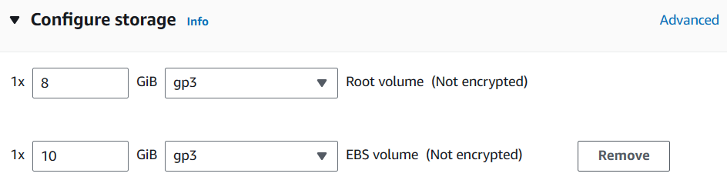

Launch it.

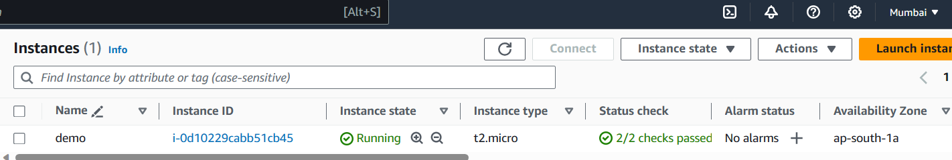

Switch to Singapore region and launch EC2 Instance which have only default root volume and no user data.

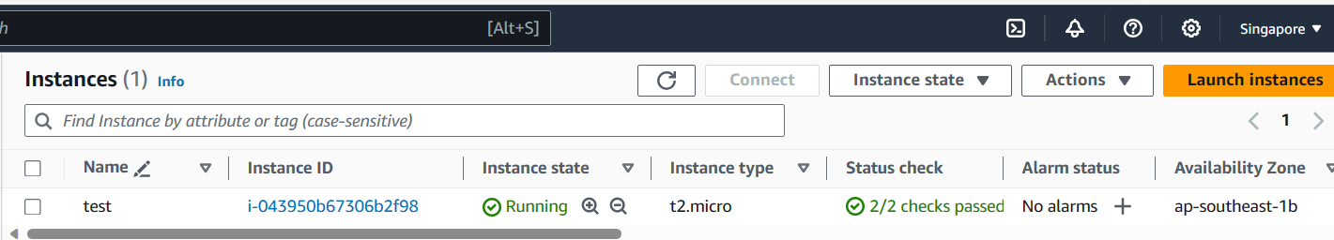

**Replicating EBS Volume from Mumbai to Singapore:**

* You cannot directly move volumes from one region to another region.
* Every region is independent.

**Mumbai Region:**

**Step 1:** Convert the volume to snapshots.

Volumes > Actions > Create Snapshot

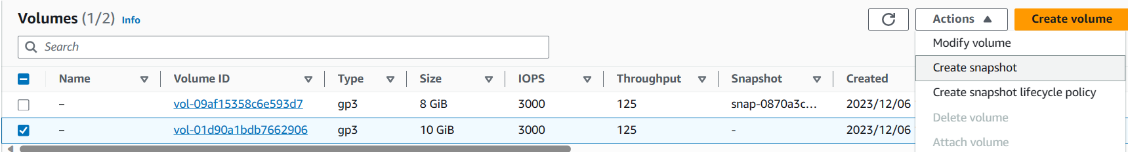

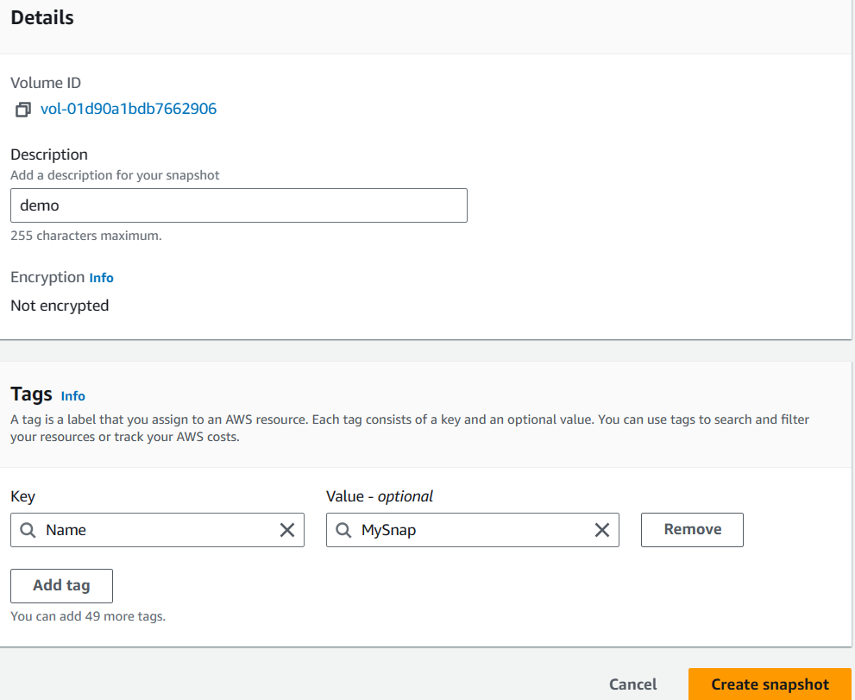

**Step 2:** Copy the snapshot to Singapore region.

Snapshots -> Actions -> Copy Snapshot -> Specify destination.

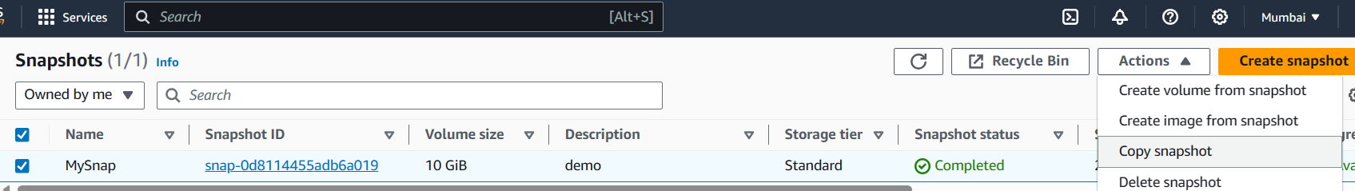

Note the availability zone of the machine in Singapore.

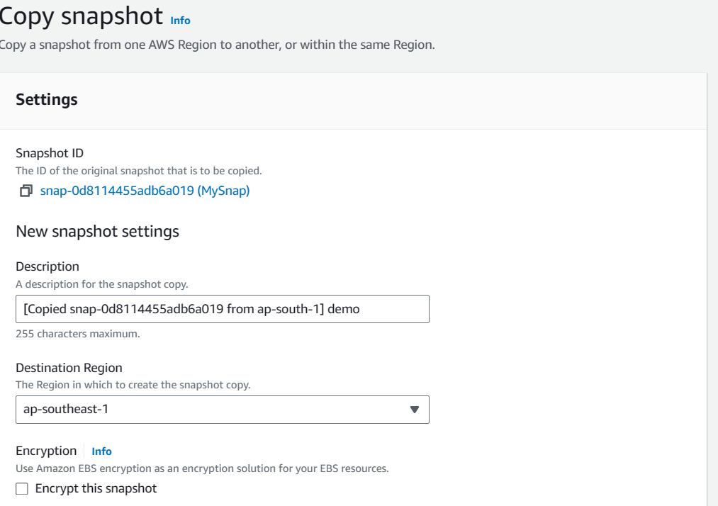

**Switch to Singapore Region:**

**Step 3:** Convert snapshot to volume and attach it.

Snapshot > Actions > Create volume from snapshot.

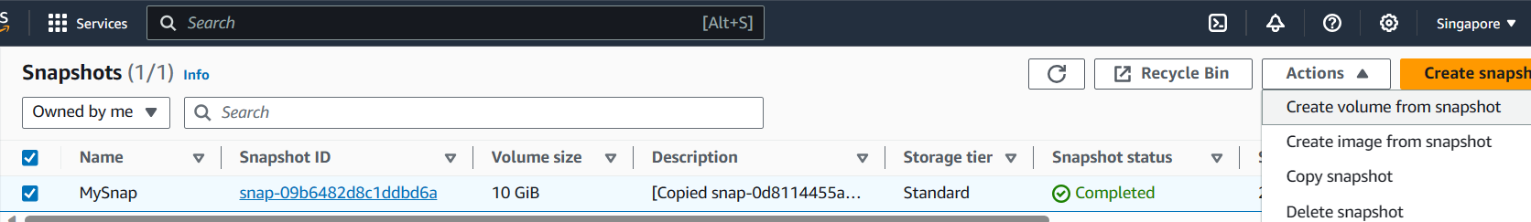

Make sure to choose the availability zone where your instance is launched (e.g., ap-southeast-1b).

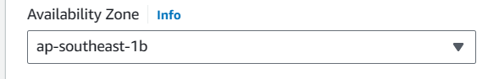

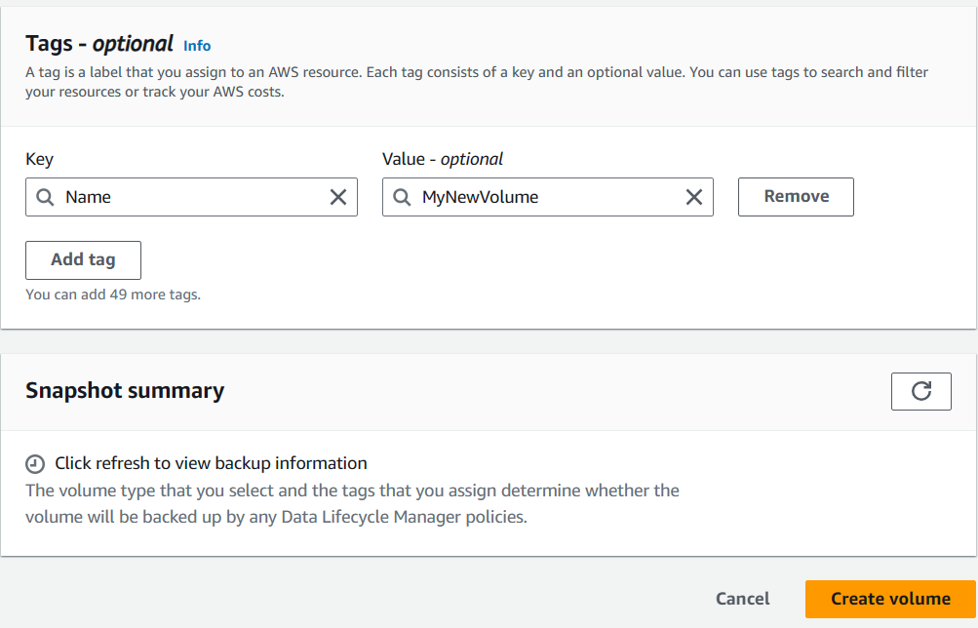

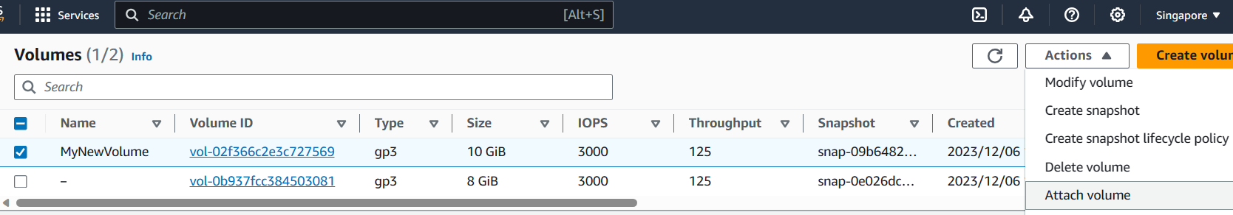

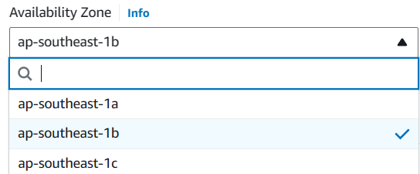

Choose your instance and attach it.

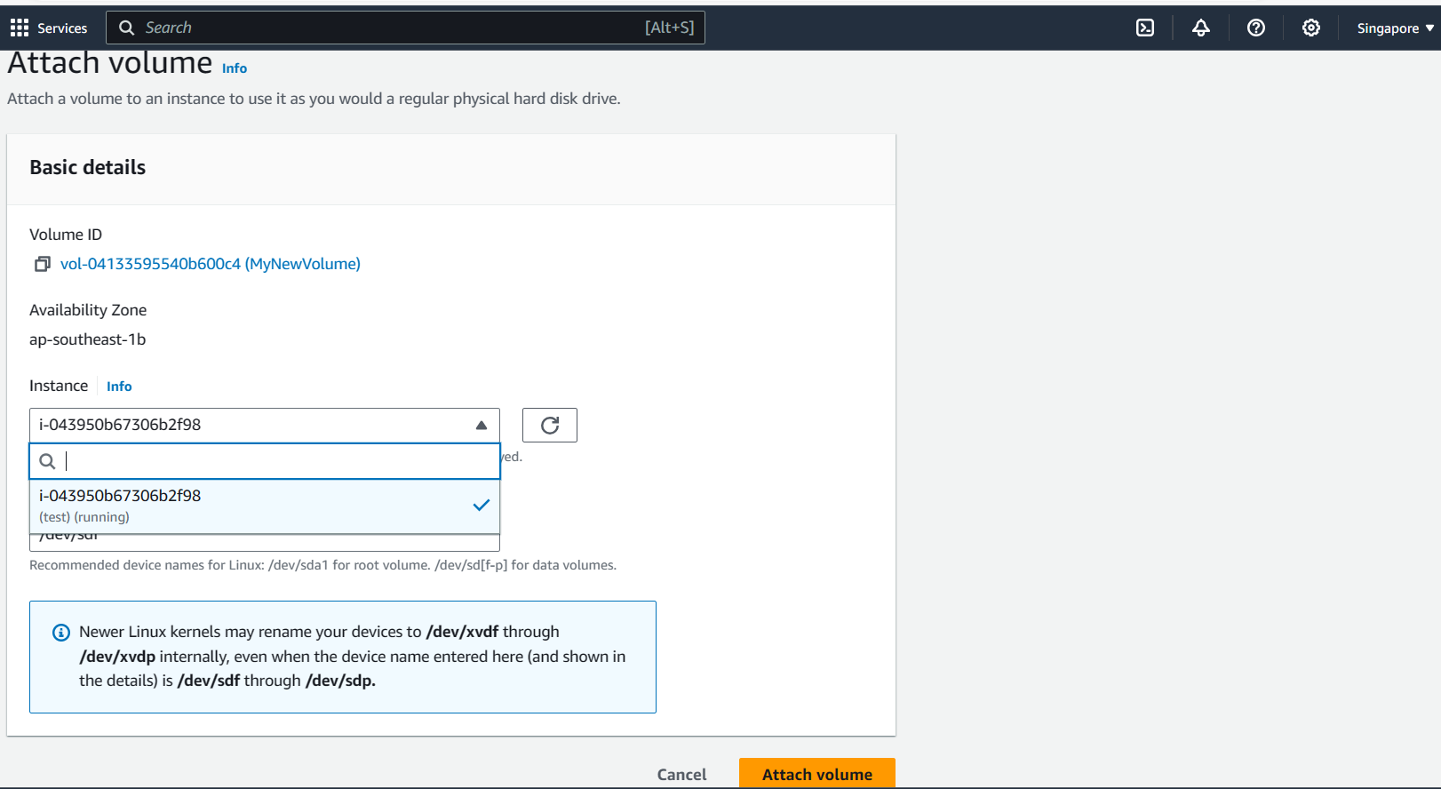



EBS volume successfully attached from Mumbai to Singapore.

**Snapshots and AMI:**

* **Snapshots:** Copy of a volume.
* **AMI (Amazon Machine Image):** Copy of the complete instance; refers to the copy of **the root volume.**

**Replicating Instances**

**Scenario:** Replicating a demo instance with software from Mumbai to Singapore.

To replicate the instance, we can create the image of the instance.

**Mumbai Region:**

* Create an image (AMI) of the instance.

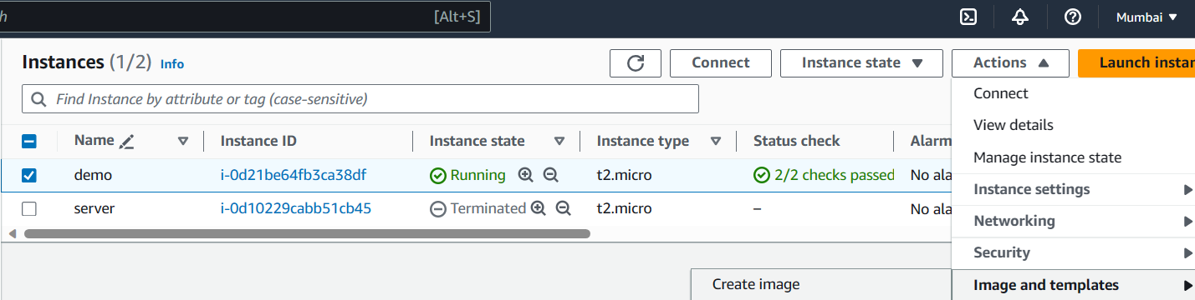

* Declare image name and create it.

The instance AMI is created in the same region.

Copy the AMI to the destination region.

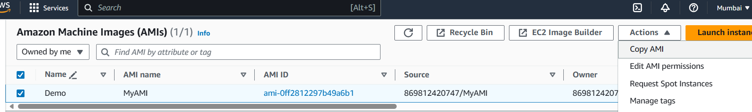

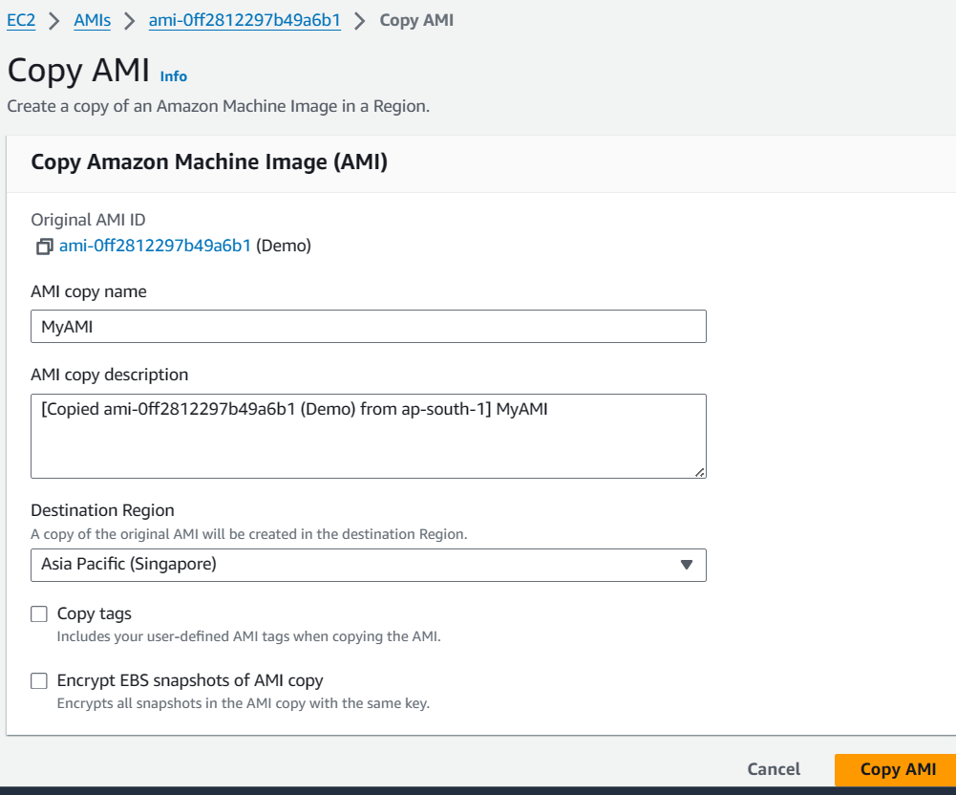

It can take few minutes for the AMI to be copied. Once the AMI is available you can launch instance.

**Switch to Singapore Region:**

* Launch instances using the copied AMI.

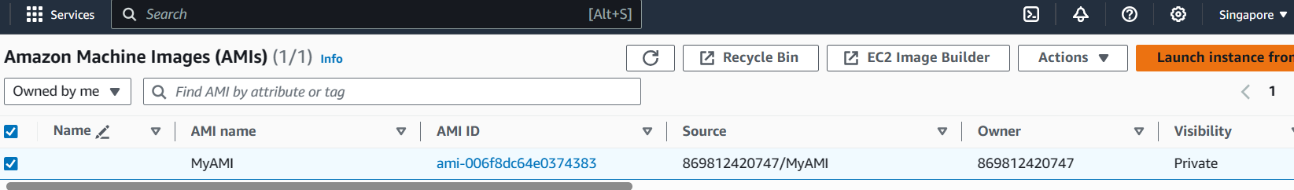

Choose MyAMIs Owned by me and select keypair and launch it.

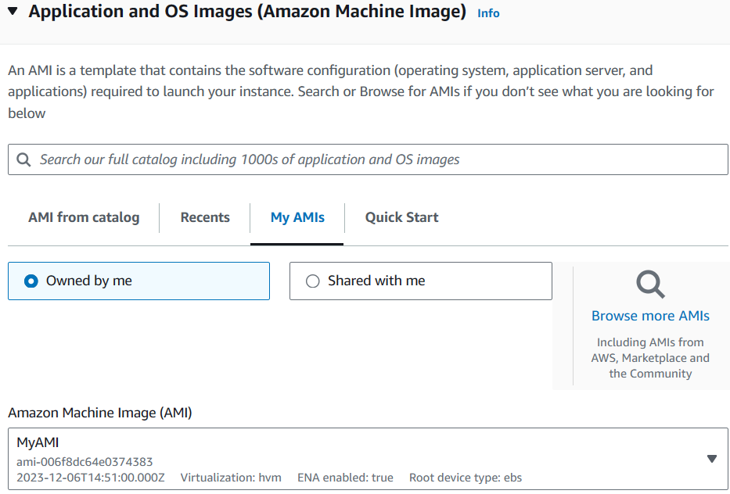

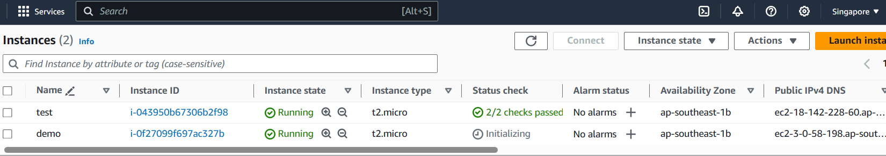

Successfully replicated instance in Singapore with the same configurations and software.

**Deleting Process:**

**1.Stop and Terminate EC2 Instances**

2. **Delete EBS Volumes**

**3. Deregister AMIs**

4. **Delete EBS Snapshots**

**5.Delete security groups except default and key pairs.**